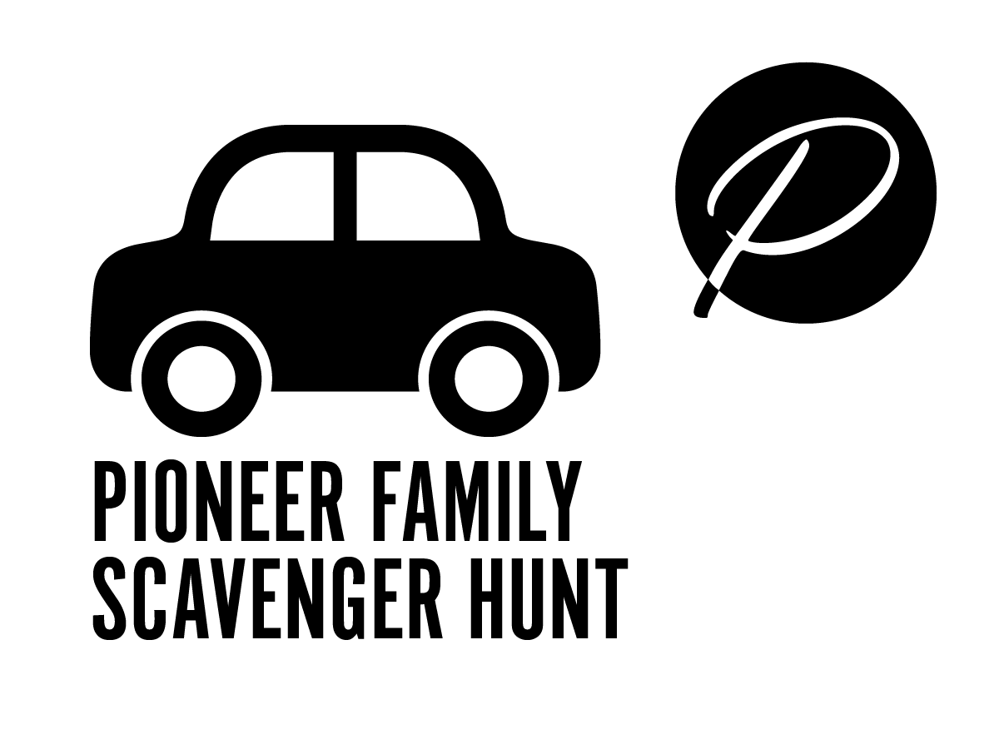
STORY 2: FRIEND

Not feeling well, a teacher went to the Battle Creek Sanitarium - an Adventist health center - for treatment. He was a very smart man that loved people. As he was working in the garden one day, two young boys walked by greeting him and then stopped to learn more about what he was doing. Edson & Willie lived near this health center with their parents, James and Ellen White. As the boys chatted with this friendly man, he was able to answer schoolwork questions in ways that made such sense. This really helped the boys who had been struggling without a good teacher.
The boys were so excited about their visit that they told their parents all about their neighborly chat. They wondered if their parents might invite this man to be their teacher as he was better at explaining things than any teacher they have ever had.
Willie and Edson’s parents, along with some other pioneer parents, soon invited this teacher to open a small private school in Battle Creek, which is not far from Berrien Springs, Michigan. They learned a lot from their new teacher; and this became the first Adventist school.
Among other fun learning adventures, this teacher started the “Cozy Club” for students who enjoyed reading good books. And while students learned a lot, he was very strict at times. He liked things to be precise and perfect. One day he called on one of his students to read a lesson out loud. The students took too long to find the reading and respond so he asked him if he was sleeping, and asked the student next to him to help this slow student to his feet. Even when strict, his students all loved and appreciated him because he was so friendly.
Indeed, teacher Goodloe Harper Bell was a friend that cared about his many students and wanted them to love and live for Jesus. Bell Hall on the Andrews campus was named after this pioneer Adventist teacher - and teachers are still being trained here today.

DIRECTIONS:
- Use this map to find the building named after this pioneer on the AU campus.
- Find the scavenger guard with a friend-making activity near a flag.
- When you’ve done the activity, look for the flag with the word to text to 269-281-2345 for the next exciting pioneer story with clues to your next stop.

