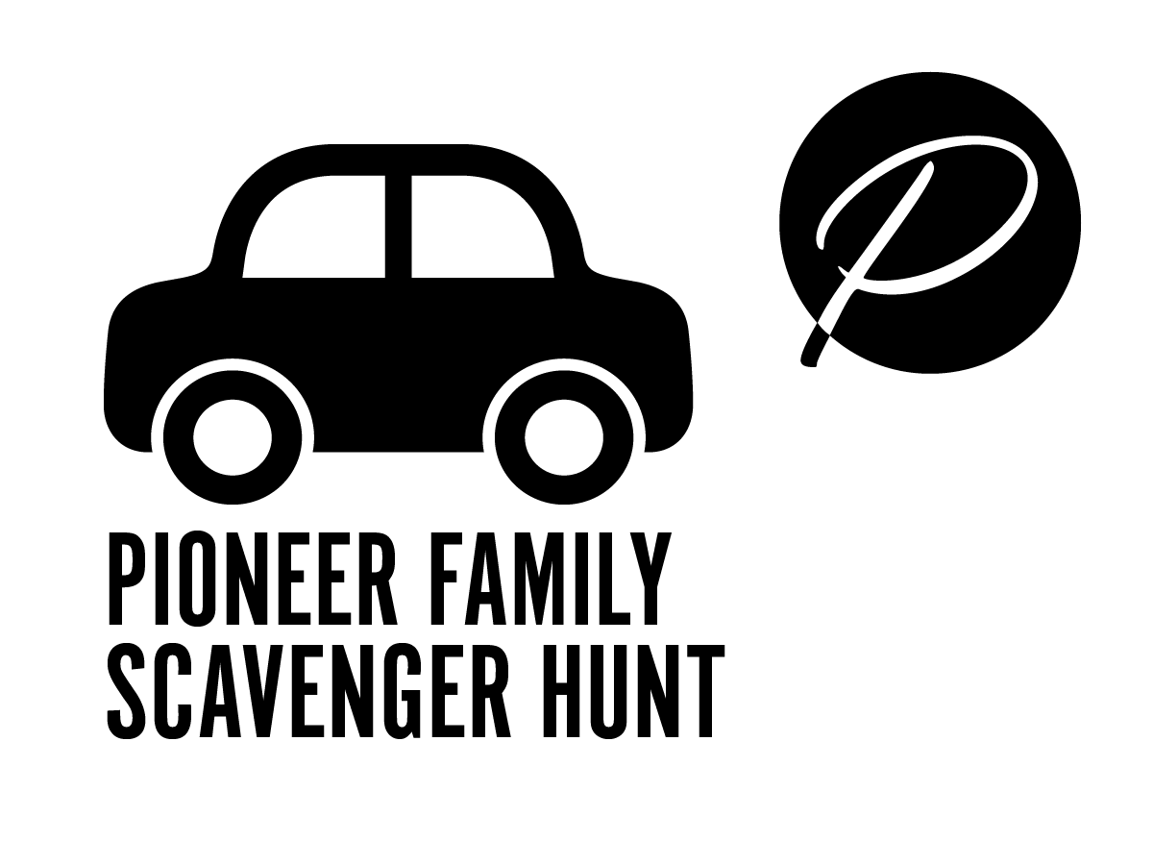
STORY 5: LOVE

Upon finishing high school, this young man decided he would work with his dad as a farmer. But one day he suddenly decided to take the test for a teacher’s certificate even though he hadn’t been considering being a teacher. Doing really well on this test led him to become a teacher instead of a farmer.

After two years of teaching he took a trip to visit his sister who was studying at Battle Creek College. This trip changed his life unexpectedly again. In addition to enjoying the visit with his sister, he met a beautiful young lady, Blanche Eggleston who he liked a whole lot. He was also invited to become the principal of the younger students preparing for college. He chose to accept this job and eventually married Blanche. From
this start in Battle Creek, he would continue to have a big impact on Adventist education for the remainder of his life.
This man cared a lot about those that didn’t have schools to attend. After thinking about how to help he decided to start a new kind of school where students who did not have school buildings nearby would still get a chance to learn. He knew there were children of missionaries and others who wanted their children to attend a school that helped them learn about God and His world through all their classes, but were not able to find such a school where they lived. He decided to start a school that mailed lessons to these students.
Every chance this man had he helped to make things better in schools. He made sure that children would be able to get a good education. He also did everything he could to help teachers and all schools improve. Mr. Frederick Griggs loved people and because of his love for people and education many children and grown ups around the world were able to learn to love and live for Jesus around the world.
Griggs International Academy is named after this pioneer. The teachers and school leaders work in Griggs Hall, helping children study online from their homes in many countries.

DIRECTIONS:
- Use this map to find the building named after this pioneer on the AU campus.
- Get ready to take a family photo, showing what you ‘scavenged’ at each station on this hunt. You may take a selfie in your car or jump out and a scavenger guard will take it for you.
- Then look for the flag with the final clue word, to find out how to enter into a drawing for a prize for completing this first scavenger hunt.

